

1
Using EAN Database Geographical Regions

EAN Partner:Connect
Jon Arce

Overview

As part of EAN’s offerings to partners, we create and maintain a full set of relational files (34 in total), as well as custom scripts to automatically manage and update your local database file collection.

In this paper we focus on the Geography content of the files as per Expedia definitions of regions. For Expedia a region is considered a “marketing region”, a bucket of hotels that represent a geography related search term, like cities, airports, landmarks and neighborhoods. Think of it like places people will search in order to find hotels located inside or close to it.

Lets start by describing the relationship between the different Expedia regions.

EAN Hotels

The ActivePropertyList is the table containing all hotels of our inventory. There are various geography related field that you could use as you can see in this example:

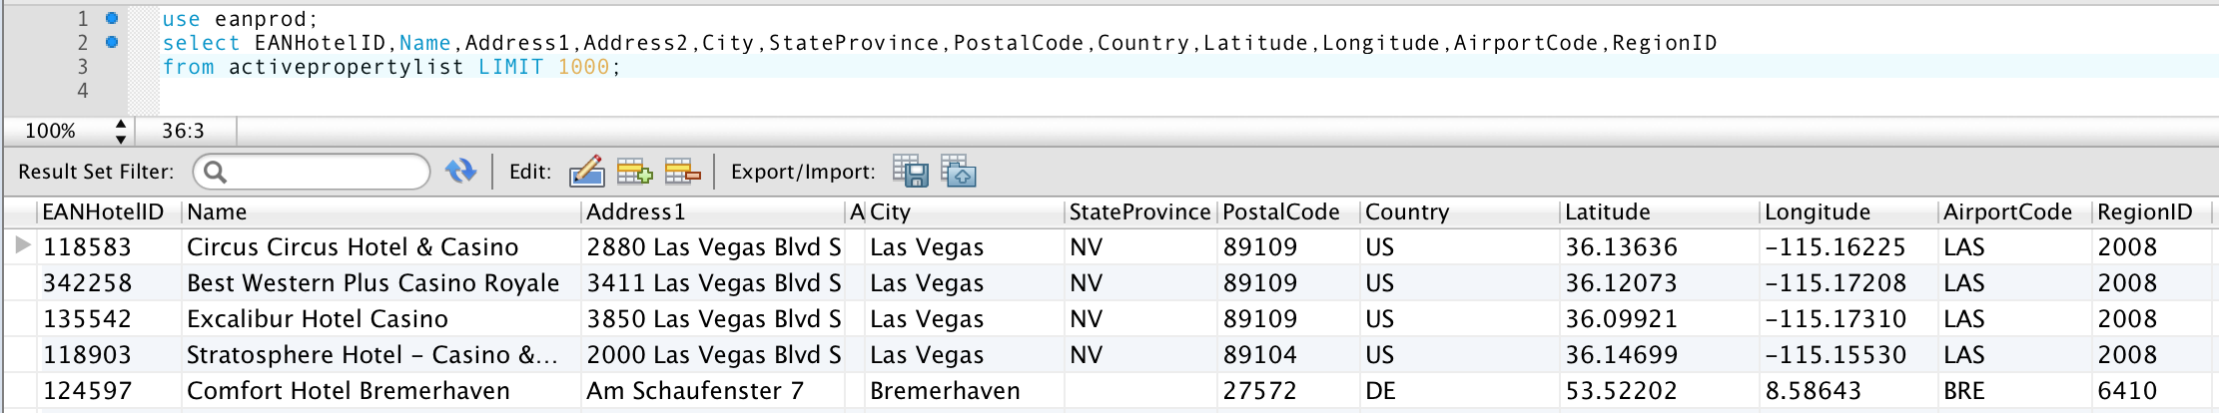
Our recommendation is NOT to use any of those fields to solve the geography. As this is data collected and maintained directly by the hotels. Here is a list of the available fields and combinations and why we do NOT recommend it:

- Hotel address - Hotels normally will use what is called their 'vanity address' (and address that is somehow favorable for a traveler to select). Classic examples hotels using 'Orlando, FL' while they are really in other city.
- PostalCode – Some hotels use their mail postal code instead of the real location code, or change it to match their 'vanity address'. Also the codes strings are NOT normalizing so we have different usage of uppercase/lowercase letters and separator characters.
- AirportCode – The IATA AirportCode repond the question of “If someone arrives from the USA, to your hotel, what Airport they most likely use”. Is unreliable as there are many hotels that service regional airports that do not directly receive USA traffic and are more relevant. You could make a distance calculations by the GPS point of the hotel vs the Airport to validate proximity.
- Latitude, Longitude – The GPS point location of the hotel, are improving on quality every day, as we use them to display the property on a map. We have created specific stored procedures and documentation on how to search by GPS location, please check our WhitePaper: Using EAN Databases for Geographical Solutions.
- RegionID – This field value represent the Main EAN Region, but it is NOT the only one where an hotel belongs, as a preference Expedia map them to to a “Multi-City (and Vicinity)” type.

We will now clarify the proper way of mapping properties based on their geographycal associations.

EAN Region (City Tables)

The most basic way of mapping an Hotel is to a City. We have two tables that represent a list of Cities in our database files, those are:

- CityCoordinatesList – List the cities and the coordinates that define the region over a map. Remember our regions do NOT intend to match a city definitions (but match it close-by). This is mainly used to create map overlays to allow click and searck functionality or when you need to display the geography od the area where that hotel is located.
- RegionCenterCoordinatesList – List the CenterLatitude and CenterLongitude of the particular region, it could be used to calculate distance (like using Haversine formula) in relation to any give point. Be careful as sometimes the Center is considered the downtown of a City and it is NOT the mathematical center of the region. It is used best when searching for hotels close to the Region Center by GPS location. Please check our WhitePaper: Using EAN Databases for Geographical Solutions.
- ParentRegionList – This table includes all regions, and allow you to know how is the Parent of that region. Basically is a chain, starting from the Country level, down into State-Provinces, then into Cities. It does include a lot of variants and will be properly explained in our next section. This is the Main table to use to get all possible regions.

EAN Region (ParentRegionList)

The ParentRegionList table is the single most important source of geography information, if you need not to draw a region, or know their polygon coordinates or center, if you just care about a list of locations and extract the list of EANHotelIDs in that region – this is your table.

Parent Region List express also the hierarchy of Regions starting at the Continent level, drilling down into the State-Provinces and then into Multi-Regions, Cities and Neighborhoods. The names on this table are also available in multiple languages by downloading additional files (we cover that in a latter section).

Let start by looking at a sample of Hierarchy drill down:
Region ID | RegionType | Name | Parent ID
500001 | Continent | North America | 0 (nothing above this level)
201 | Country | United States of America | 500001
230 | Province (State) | Nevada | 201
6054173 | Multi-City (within a country) | Clark County – Las Vegas | 230
178276 | Multi-City (Vicinity) | Las Vegas (and vicinity) | 6054173
2008 | City | Las Vegas | 178276
800045 | Neighborhood | The Strip (Las Vegas) | 178276
6232223 | Point of Interest Shadow | Welcome to Fabulous Las Vegas Sign | 2008
6232224 | Point of Interest | Welcome to Fabulous Las Vegas Sign | 6232223

Lets clarify that this is just a representation of the data and NOT the full possible targets of a drill down. For example at the “Multi-Region (within a country)” level for Nevada we got: Clark County – Las Vegas, Central Nevada, Western Nevada, Northern Nevada – Humboldt River and South Nevada. As well there are many other cities inside the Clark County – Las Vegas definition.

First clarification is that this are travel related terms, not the proper political map of Nevada, if we are to follow that, in the case of USA, we will be based out of counties and then into cities. Remember this is NOT a geo-political system!

In case you ask can a City have a child region? Yes, indeed it could be a neighborhood name, but also we have the Point of Interest (Landmarks) that are inside that city. (However you will first get the “Point of Interest Shadow” types as a container for the true “Point of Interest”. There is no usage for the “Shadow” other that it was necessary for the original relational database model to manage the information. We discuss a better way to get the Point of Interest in their own section.

You could actually search at any given level and obtain a list of hotels, however as a general rule, you start at the city level your searches. Let's now look at how to query to get the most common data we need.

EAN Region (Cities)

We map cities to their more desirable locations and create a multi-polygons region. Easier to understand if you visualize it; following the “Las Vegas” example:
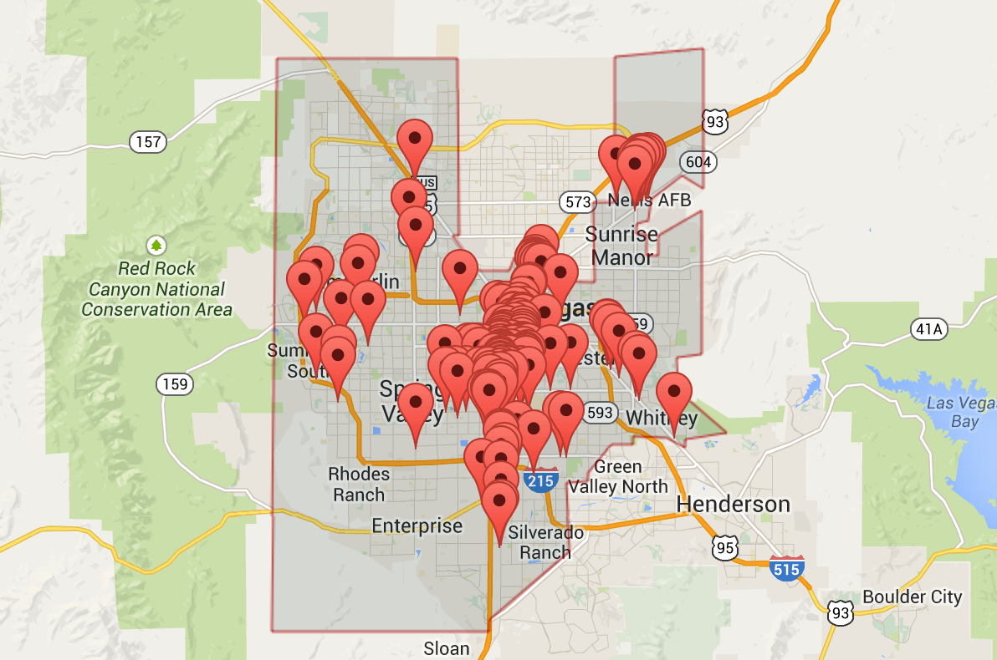

You can see that a city region is not a mere square over a city, but a hand-pick of regions that converts better for the travelers. We aim for quality and not for quantity.

Query for Cities (technical)

To get a list of Cities from our database you have two possible sources, using the CityCoordinatesList or filter out the information from the ParentRegionList.

Let's look at using the CityCoordinatesList for a query:

USE eanprod;
SELECT RegionID,RegionName FROM citycoordinateslist;
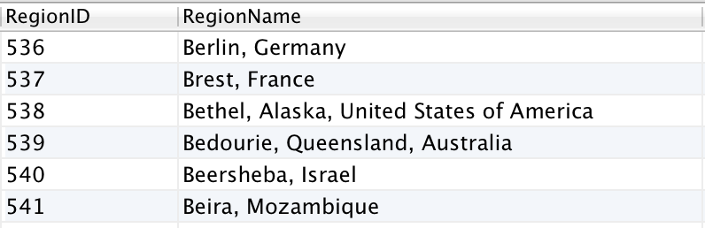

66137 row(s) returned.

Notice you will have to parse the RegionName to extract one of two formats:

City, State-Province, Country

City, Country

This is due to the fact that we do not have state-provinces for all countries. It is easy to detect by the amount of commas in the RegionName string.

The second possibility will be using the ParentRegionList table, with the query:

USE eanprod;
SELECT RegionID,RegionNameLong FROM parentregionlist
WHERE parentregionlist.RegionType IN('City');
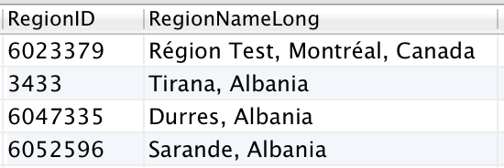

66137 row(s) returned.
You notice both queries produce the same amount of results, however in the ParentRegionList query, we are including all types of SubClass. If we look deeper into the SubClass field (for RegionType that are City):

use eanprod;
select RegionID,RegionNameLong,RegionType,SubClass FROM parentregionlist
WHERE parentregionlist.RegionType='City' AND SubClass <> '';
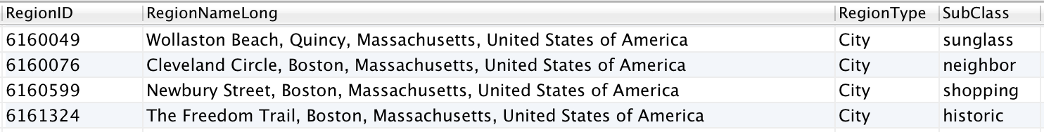

notice that we get back SubClass like:
- sunglass – a beach or beach-front location
- neighbor – neighborhood names (this set could be desirable to include)
- shopping – shopping malls, districts or famous shopping streets
- historic – historic trails or landmarks

We do NOT want those in our query, well maybe the Neigborhood names, but definitively they are NOT cities. We need refine the City query to be:

USE eanprod;
SELECT RegionID,RegionNameLong,RegionType,SubClass FROM parentregionlist
WHERE parentregionlist.RegionType='City' AND SubClass='';

This is our recommended way of getting the list of Cities.

EAN Regions (query for (and vicinity))

For most mayor city markets, those that people all over the world know like: Paris, Las Vegas, Orlando, Miami, London, Tokyo, etc ….. Expedia utilize the concept CityName (and vicinity), this is a special geographic region that covers the best possible areas inside the city and close to it, that in our analysis, customer prefer when searching for that city. The idea is to present a mix of classics and off path properties. Expedia create choose those key areas, an they normally convert more revenue that the plain CityName areas. If you want to follow the Expedia model, when customers look for the CityName, show instead results for the CiityName (and vicinity) instead.

In our previous example we used just the City of 'Las Vegas”, now let's look at the “Las Vegas (and vicinity)” region:
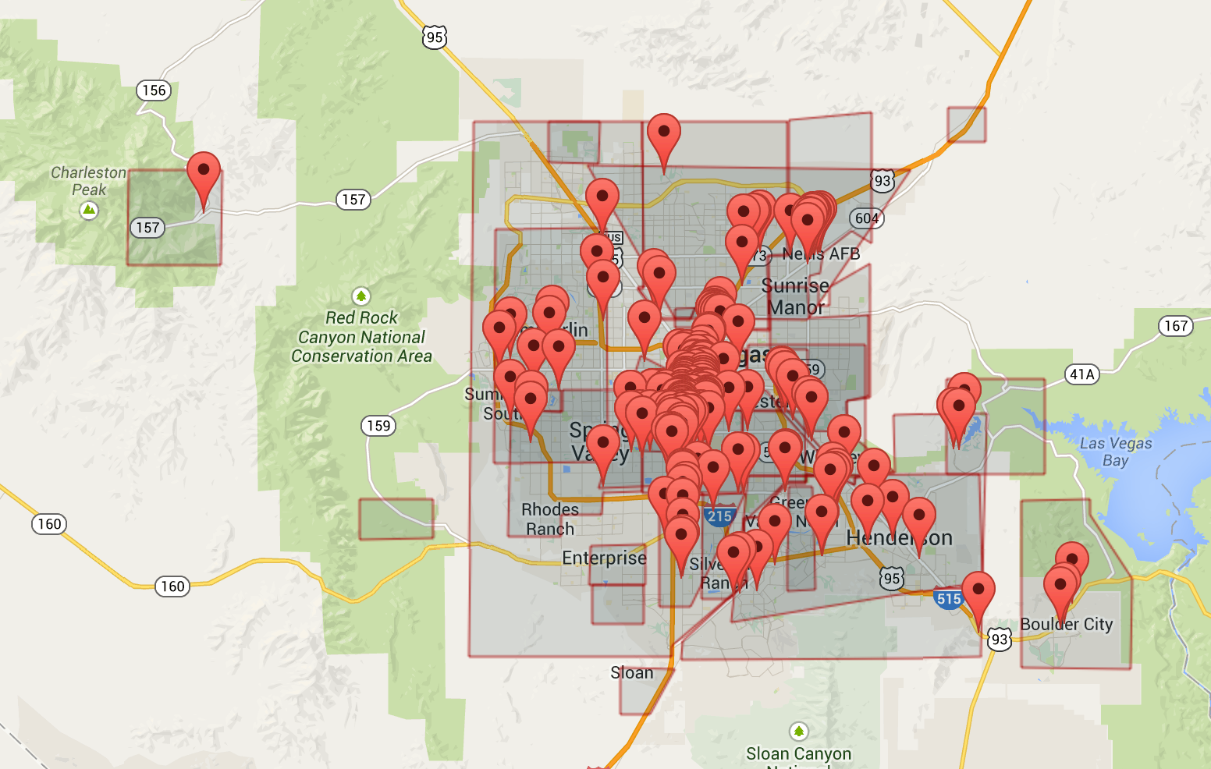

If you analyze the Expedia site, you will notice that for Las Vegas market, we present two options: “Las Vegas (and vicinity)” and “Las Vegas strip”. Lets look now at “Las Vegas Strip” region:
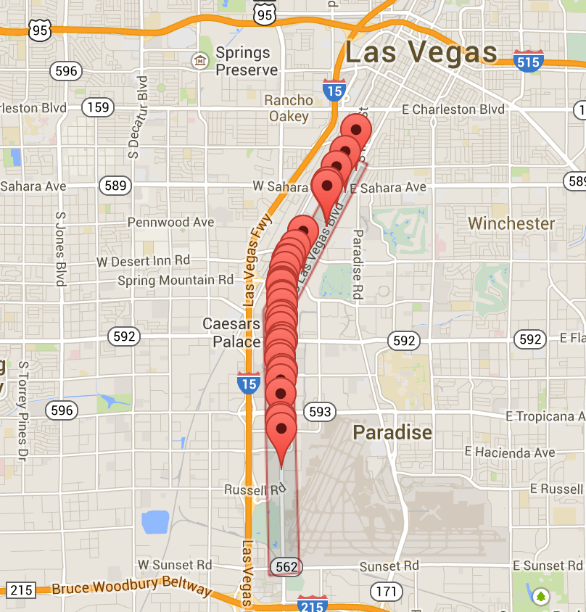

Region Names in other Languages

For each of the 34 languages that we support, there is a single file that will include the translations. Those are names RegionList_xx_xx, last part of the name is the locale. For example the spanish from Spain translation will be named: RegionList_es_es, for Brazilian Portuguese: RegionList_pt_br.

Autocomplete
An autocomplete is the typical feature used on traveling websites, that allow the customer to type any word and after a few characters it present a possible list of 'complete' terms. Applied to traveling search we can see such function in our own Travelnow site like:

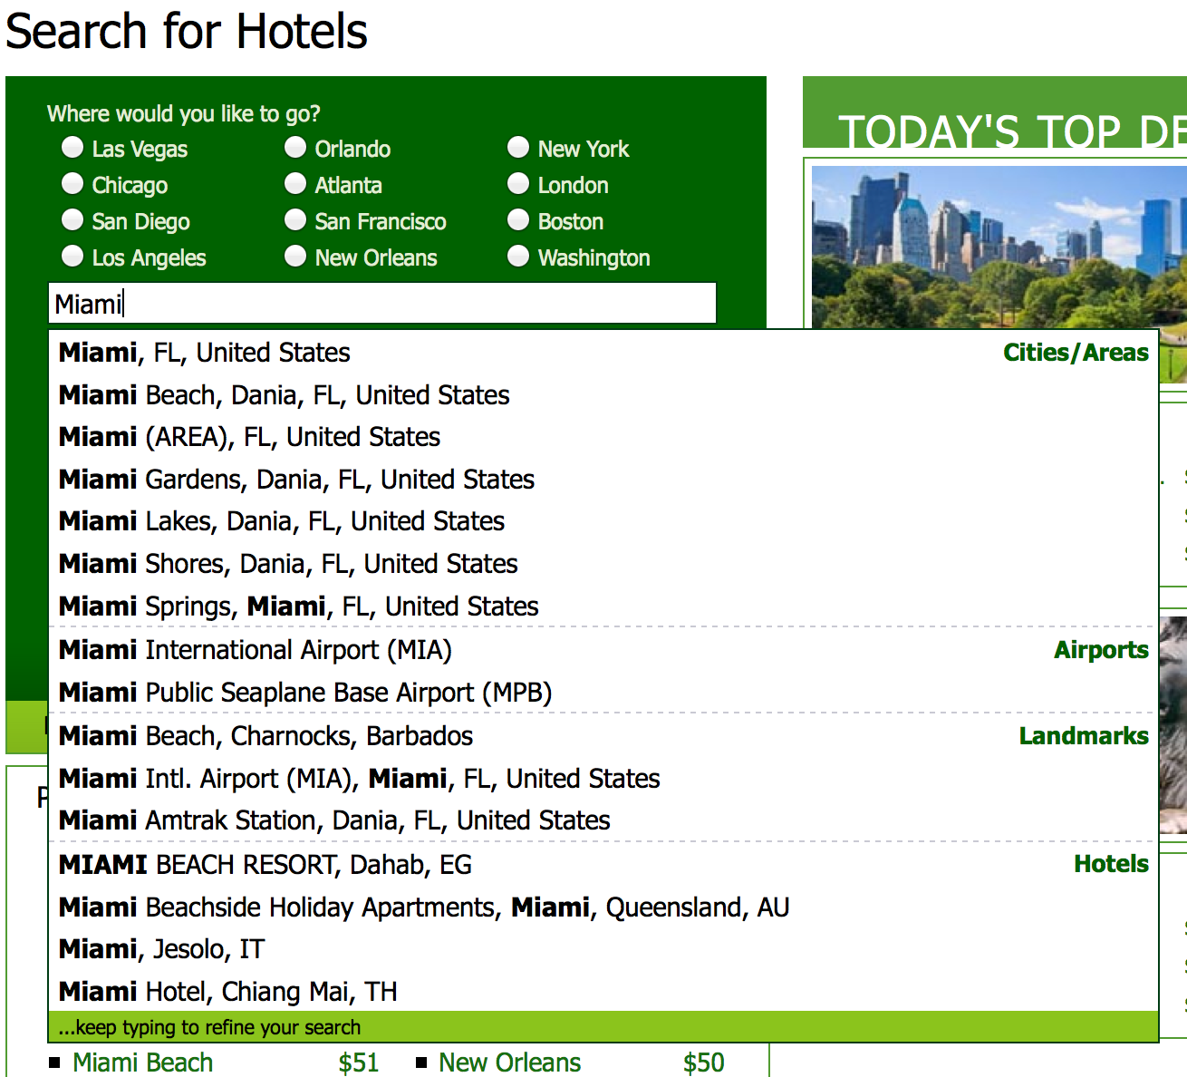

You can see they have classifications like: Cities / Areas, Airports, Landmarks, Hotels. Using the suggested queries presented in this document we could create a list with their region id, that you can use to present this information, and when selected use the RegionID to discover the list of EANHotelIDs to send to the EAN-API as a list of <hotelIdList>.

For our sample Autocomplete we create a table with fields like:

Real Location (reverse geocoding)
Some people ask us, if we maintain a list of 'real' address of hotels, landmarks and cities. AS you can tell we do not follow a 'precise' geo-political (think on ISO standardized regions) mapping of the world. We understand there are multiple scenarios when that is desirable, necessary as:

- Multi-supplier scenarios – Trying to compare an hotel from one supplier to know if it Is the same as another supplier.
- Map based applications – using for example Google maps as search or display template.
- Data re-hash – like combining multiple transportations (train, taxis) pre-calculated as supplemental information to travelers
- More precision on Neighborhood information – For example in Latin America and also Spain & France, there are multiple neighborhood names for a place.
- Postal Codes – We do not include the postal codes on all address, or they are not normalize you may need this info. For maps.

In those case you are probably looking at what is know as reverse-geo coding. Reverse geocoding is the process of back (reverse) coding of a point location (latitude, longitude) to a readable address or place name. This permits the identification of nearby street addresses, places, and/or areal subdivisions such as neighborhoods, county, state, or country.

Basically you could use an online service (pay or free) or even create your own server to solve this information. Here is a list of some know APIs to do such operation:

- Google Geocoding API – paid after certain limit
- Bing Maps API (Locations API) – paid after certain limit
- Yahoo! (Boss Geo Services) – paid after certain limit
- MapQuest Geocoding API – paid after certain limit
- Nokia Geocoder API – paid after certain limit
- OpenStreetMap (Nominatim API) – free (but limited amount of request)

Almost all of the services will let you subscribe and send an amount of request per a period of time (days) before you need to purchase a license. In our discoveries they are quite similar in functionality but varies a lot of data quality. Unfortunately the variance is based on backends so some may work better than others for any given country. The only free one is the OpenStreetMap (via Nominatim API), but if you send a vast amount of consecutive request they will block your access.
You could deploy your own OpenStreetMap and install the Nominatim layer on top, but it does require a quite powerful Server and a lot of time investment to get it up and running, as well as maintaining it (be sure you really need it).

Reverse geocoding (technical example)
Let use the free Nominatim API to make a reversegeo request from an hotel. Searching for hotels in 'Les Angles, Fr':

If we use the first hotel, you will notice we do not know much about its address as ther eis no StateProvince for it. Constructing a RESTful call we send in:

http://nominatim.openstreetmap.org/reverse?format=json&lat=42.57622&lon=2.06994&zoom=18&addressdetails=1

We got back a JSON response:
{
"place_id": "9167865406",
"licence": "Data © OpenStreetMap contributors, ODbL 1.0. http://www.openstreetmap.org/copyright",
"osm_type": "way",
"osm_id": "88074349",
"lat": "42.5751299",
"lon": "2.0711922",
"display_name": "Téléski Bamby, Rue du Tennis, Les Angles, Pirineos Orientales, Languedoc-Rosellón, Metropolitan France, 66210, France",
"address": {
"address29": "Téléski Bamby",
"road": "Rue du Tennis",
"village": "Les Angles",
"county": "Pirineos Orientales",
"state": "Languedoc-Rosellón",
"country": "France",
"postcode": "66210",
"country_code": "fr"
}
}
You can tell that the address is more detailed in this response (also disassemble in its elements) than the one we have on file, you could use this information as seed to discover property matching in multi-supplier environments.

Multi Hotel Supplier Lists

In the case of just matching a list of hotels with the ID of another supplier, we have work with a couple of supplier that sell that services. They are based on subscription lists, their listings include location information and we are mentioning it here as it been helpful in some partners implementations. Companies are:

- GIATA - GIATA Codes identify more than 362,000 individual hotels and hotel complexes, including details of the town/city and country.
- Match2List – They already have pre-created list of our inventory matched to other suppliers (you need to send them an email to request that product).

Conclusion

We have discussed the various geographical information and data tables that Expedia makes available to their partners. However we cannot give you a simple geography file that will fit all scenarios, as that will depend on the specifics of your market target. Let us know if you fine this WhitePaper useful or if you need some more clarifications please send us a note at: apihelp@expedia.com .

